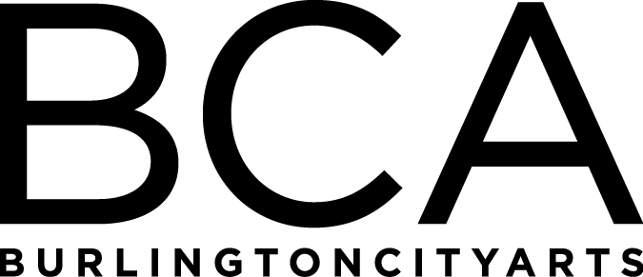

Arts Education Committee Meeting
Tuesday, November 20, 2018, 1:15pm-2pm
BCA Center, 135 Church Street, LBG, 2nd floor
In attendance: Dana vanderHeyden, Melinda Johns & Melissa Steady
- Fall ‘18 updates and comparisons to last year
Fall Adult, Youth and Family ’18 (57 offerings- 55 ran)
31 studio classes, 9 Friday Adult Wheel nights and 9 Life Drawing drop-in sessions, 9 Friday Family Clay nights, 3 Sunday Family paint workshops (NEW), 1 School Break: DIY Halloween Costumes, 1 High School Photography class for 8 weeks, 3 Professional Development workshops (Classroom Management for Teaching Artists, The Artist Statement and Photographing Artwork)
Over $37k brought in- highest ever for Fall (usually in the $28k-30k range)
Doubled amount of adult students- from 163 to 330
Scholarships awards have increased from $4,103 to $7,806

- Community Programs review
AFTH- programs offered 7 days week at UVM Medical Center
Early Arts Head Start residencies happening at King Street and Sara Holbrook
IAA residency scheduled for 280 kids from whole school and 5th grade legacy project
Children’s Art scheduled for March ’19 (180 kids honored from all 6 elementary schools)

- Gallery Education program stats comparison of FY’18 and FY’19 to date
FY 2018
Total number of participants in all groups = 1684
Total number of groups/tours/programs = 64
Total number of STD youth groups = 36
Total number of youth served in school groups = 521
Total number of teachers and adults=188, total number of teachers = 138
Total number of university group visits = 9, Total number of university students served = 196
Total number of adult and senior groups = 3, total number of adults = 19
Total number of participants FAS = 741
Total Scholarships awarded: 280 students / $1400 value
Total Program Revenue FY 2018 | $1,615.00

FY 2019 to date
Total number of participants in all groups = 706 (coordinated additional 135), est. 841
Total number of groups/tours/programs = 35
Total number of STD youth groups = 20
Total number of youth served in school groups = 342
Total number of teachers and adults = 80
Total number of university group visits = 4, Total number of university students served = 80
Total number of adult and senior groups = 3, total number of adults = 15
Total number of participants FAS = 166 / 5 months
Total Scholarships awarded: 115 students / $575 value
Total Program Revenue FY 2019 | $860.00

Offering another contracted after school 8 week class with Edmunds Elementary, Dec 3-Feb 11, 2019 (Revenue est. $720)
Partnerships with Bridging Program and Family Room Preschool
- New program partnership in Fall 2018 with Fletcher Free Library/Free Storytime / served 24 participants
New program initiatives
- Art & Conversation / Free public program for older adults / Pilot March 2019/ AARP grant
Upcoming Highlight Event
- Gallery Education activity / past attendance
- Support of Highlight Lantern Activity
FY’19 Meetings:
Tuesday, January 15, 1:30-2:30pm, BCA Studios, 405 Pine Street
(Board Meeting: 3-5 pm at BCA Center)

Tuesday, March 19, 1:30-2:30pm, BCA Studios, 405 Pine Street
(Board Meeting: 3-5 pm at BCA Center)

Tuesday, May 21, 1:30-2:30pm, BCA Studios, 405 Pine Street
(Board Meeting: 3-5 pm at BCA Center)

Tuesday, June 18, 1:30-2:30pm, LOCATION: TBD
(Board Meeting: 3-5 pm at BCA Center)

Arts Education Committee
The Arts Education Committee includes BCA board members and non-board members and meets 6 times annually. Members of the Arts Education Committee provide experience and expertise in various aspects of life-long learning and connect BCA programs to trends and themes in arts education. The committee evaluates, advises and guides the art education programs, which include education studios, classes, camps and workshops, school artist-in-residence programs at IAA and with Head Start, afterschool programs and Art from the Heart at UVM Medical Center.

