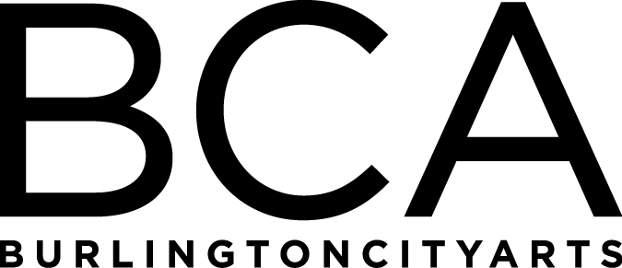

Arts Education Committee Meeting
Tuesday, May 21, 2019, 1:30pm-2:30pm
BCA Center, 2nd floor (LBG room), 135 Church Street
Agenda:
- Scholarships review
- Class, Community Program and AFTH updates
- Gallery Education updates

FY’19 Meetings:
Tuesday, June 18, 1:30-2:30pm, LOCATION: TBD (SEE CAMP IN ACTION?)
(Board Meeting: 3-5 pm at BCA Center)

Arts Education Committee
The Arts Education Committee includes BCA board members and non-board members and meets 6 times annually. Members of the Arts Education Committee provide experience and expertise in various aspects of life-long learning and connect BCA programs to trends and themes in arts education. The committee evaluates, advises and guides the art education programs, which include education studios, classes, camps and workshops, school artist-in-residence programs at IAA and with Head Start, afterschool programs and Art from the Heart at UVM Medical Center.

